24CSI024-DATA STRUCTURES AND ALGORITHMS
UNIT 1-INTRODUCTION TO DATA STRUCTURES AND ALGORITHMS
Arrays and Array-Based Techniques (Two-Pointer, Sliding Window, Prefix Sums)
LAB WORKBOOK-09.07.2026

CATEGORY: EASY

Question 1: Squaring a Sorted Array (Two-Pointer)
Anjali is processing seismic intensity readings stored in a non-decreasing sorted array. The readings can contain negative values (representing reverse-phase wave intensities) as well as positive values. To calculate the kinetic energy of these waves, she needs to square each value and return a new array containing the squares, sorted in non-decreasing order.
She must perform this operation in 𝑂(𝑁) time using the two-pointer technique:
- Initialize a left pointer at index 0 and a right pointer at index N - 1.
- Compare the absolute values of arr[left] and arr[right].
- Square the larger absolute value and place it at the end of the output array (starting from index N - 1 and moving backwards).
- Move the corresponding pointer (left inward or right inward) and repeat until the output array is filled.
- The first line of input consists of an integer 𝑁 representing the number of readings.
- The second line of input consists of 𝑁 space-separated integers representing the sorted wave intensities (can contain negative numbers).
- Print a single line of 𝑁 space-separated integers representing the sorted squared values.
- 1 ≤ 𝑁 ≤ 10000
- −10⁴ ≤ 𝑎𝑟𝑟[𝑖] ≤ 10⁴
- The input array is sorted in non-decreasing order.
Input 1: codeText
5
-4 -1 0 3 10 Output 1: codeText 0 1 9 16 100 Input 2: codeText
4
-7 -3 2 3 Output 2: codeText
4 9 9 49

AIM:
To square all the elements of the sorted array containing integers and print the squared values in the sorted order using two pointer technique.

PSEUDO CODE:
Algorithm SortedSquares(arr, n)

left ← 0
right ← n − 1
position ← n − 1

while (left ≤ right) do
if (arr[left] × arr[left] > arr[right] × arr[right]) then
new_arr[position] ← arr[left] × arr[left]
left ← left + 1
else
new_arr[position] ← arr[right] × arr[right]
right ← right − 1
end if

position ← position − 1
end while

for i ← 0 to n − 1 do
print new_arr[i]
end for

C code:

#include<stdio.h>
int main()
{
int n;
scanf("%d",&n);
int arr[n];
for(int i=0;i<n;i++)
{
scanf("%d",&arr[i]);
}
int left=0,right=n-1;
int position=n-1;
int new_arr[n];
while(left<=right)
{
if(arr[left]*arr[left]>arr[right]*arr[right])
{
new_arr[position]=arr[left]*arr[left];
left++;
}
else
{
new_arr[position]=arr[right]*arr[right];
right--;
}
position--;
}
for(int i=0;i<n;i++)
{
printf("%d ",new_arr[i]);
}
return 0;
}

OUTPUT:

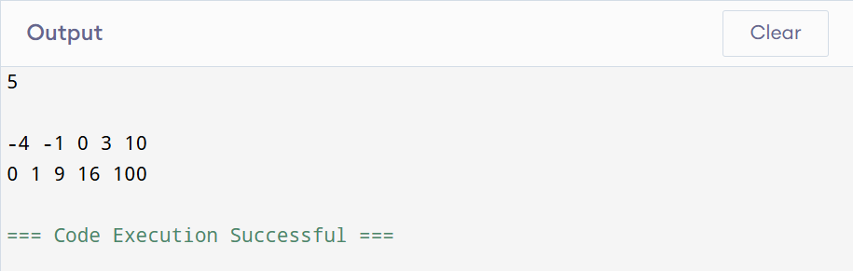

RESULT:
Thus the program executed successfully by displaying the square of the sorted elements using two pointer technique

Question 2: Cumulative Resource Consumption (Prefix Sum)
Kabir is monitoring a data transmission line. He receives a log of data packets transmitted each hour over a period of 𝑁 hours. To generate an hourly usage report, he wants to compute the cumulative running sum of packets transmitted from the start of the log up to each hour.
Write a program that takes the hourly logs and outputs the prefix sum array representing the cumulative data volume.
- Let the prefix sum array be P.
- P[0] = arr[0]
- P[i] = P[i-1] + arr[i] for 𝑖 ≥ 1.
- The first line of input consists of an integer 𝑁 representing the number of hours.
- The second line consists of 𝑁 space-separated integers representing the packets transmitted each hour.
- Print a single line of 𝑁 space-separated integers representing the cumulative running sum at each hour. • 1 ≤ 𝑁 ≤ 10000
- 0 ≤ 𝑎𝑟𝑟[𝑖] ≤ 10⁵
Input 1: codeText
5
10 20 5 15 30 Output 1: codeText 10 30 35 50 80 Input 2: codeText
3
0 0 5
Output 2: codeText
- 0 5

AIM:
To compute the cumulative running sum of packets transmitted from the start of the log up to each hour using prefix sum.

PSEUDO CODE:
Algorithm PrefixSum(arr, n)
sum_array[0] ← arr[0]
for i ← 1 to n − 1 do
sum_array[i] ← sum_array[i − 1] + arr[i]
end for
for i ← 0 to n − 1 do
print sum_array[i]
end for

C CODE:

#include<stdio.h>
int main()
{
int n;
scanf("%d",&n);
int arr[n];
for(int i=0;i<n;i++)
{
scanf("%d",&arr[i]);
}
int sum_array[n];
sum_array[0]=arr[0];
for(int i=1;i<n;i++)
{
sum_array[i]=sum_array[i-1]+arr[i];
}
for(int i=0;i<n;i++)
{
printf("%d ",sum_array[i]);
}
return 0;
}

OUTPUT:

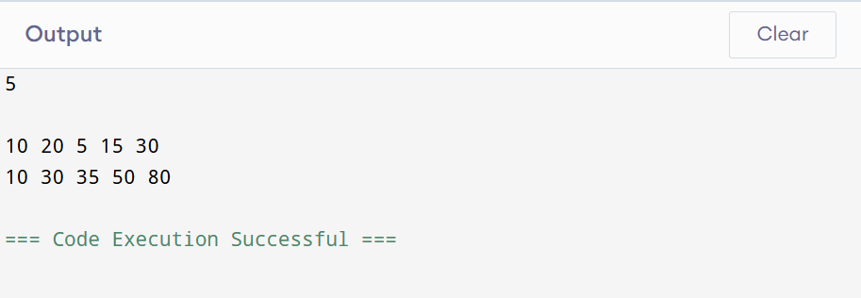

RESULT:
Thus the program successfully computes and displays the prefix sum of the given array.

CATEGORY: MEDIUM

Question 3: Grouping Active Sectors (Fixed-Size Sliding Window)
Sam is working on a flash storage defragmentation algorithm. The sectors of the storage drive are represented by a binary array of size 𝑁, where 1 represents an active data sector and 0 represents an empty sector. To optimize read operations, Sam wants to group all active sectors (1s) together in a contiguous block.
He wants to find the minimum number of swaps required to bring all 1s together. This can be solved in 𝑂(𝑁) time using a sliding window:
  - Count the total number of 1s in the array. Let this count be 𝐶. If 𝐶 is 0 or 1, no swaps are needed.
  - Find a contiguous subarray (window) of size 𝐶 that contains the maximum number of 1s.
  - The minimum number of swaps required is then 𝐶 minus the maximum number of 1s found in any window of size 𝐶.
  - The first line of input consists of an integer 𝑁 representing the number of sectors.
  - The second line of input consists of 𝑁 space-separated binary values (0 or 1).
  - Print a single integer representing the minimum swaps required in the format: Min Swaps: X.
  - 1 ≤ 𝑁 ≤ 10000
  - arr[i] is either 0 or 1.
Input 1: codeText
6
- 0 1 0 1 0
Output 1:
codeText
Min Swaps: 1
Input 2:
codeText
5
1 1 1 0 0
Output 2:
codeText Min Swaps: 0

AIM:

To find the minimum number of swaps required to bring all the 1s together in an array using sliding window technique.

PSEUDO CODE:
Algorithm MinSwaps(arr, n)
ones_count ← 0
for i ← 0 to n − 1 do
if (arr[i] = 1) then
ones_count ← ones_count + 1
end if
end for
if (ones_count ≤ 1) then
print 0
return
end if
current_ones ← 0
for i ← 0 to ones_count − 1 do
if (arr[i] = 1) then
current_ones ← current_ones + 1
end if
end for
max_ones ← current_ones
for i ← ones_count to n − 1 do
if (arr[i − ones_count] = 1) then
current_ones ← current_ones − 1
end if

if (arr[i] = 1) then
current_ones ← current_ones + 1
end if

if (current_ones > max_ones) then
max_ones ← current_ones
end if
end for
min_swaps ← ones_count − max_ones
print min_swaps

C CODE:
#include <stdio.h>
int main()
{
int n;
scanf("%d", &n);
int arr[n];
for(int i=0;i<n;i++)
{
scanf("%d",&arr[i]);
}
int ones_count=0;
for(int i=0;i<n;i++)
{
if(arr[i]==1)
ones_count++;
}
if(ones_count<=1)
{
printf("Min Swaps: 0");
return 0;
}
int current_ones=0;
for(int i=0;i<ones_count;i++)
{
if(arr[i]==1)
current_ones++;
}
int max_ones = current_ones;
for(int i=ones_count;i<n;i++)
{
if(arr[i-ones_count]==1)
current_ones--;
if(arr[i]==1)
current_ones++;
if(current_ones>max_ones)
max_ones=current_ones;
}
int min_swap=ones_count-max_ones;
printf("Min Swaps: %d",min_swap);
return 0;
}
OUTPUT:
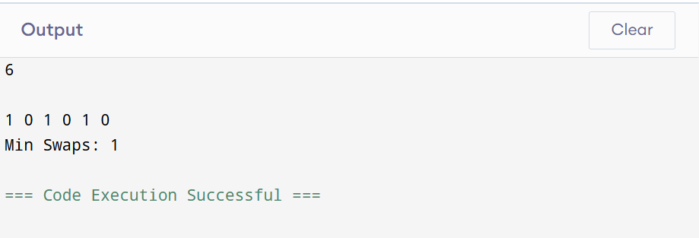

RESULT:
Thus the program finds the minimum number of swaps required to group all the 1 s using sliding window technique

Question 4: Maximum Task Window Within Budget (Variable-Size Sliding Window)
Riya is scheduling a pipeline of processes on an embedded processor. Each process 𝑖 has a known energy cost arr[i]. The processor has a strict power limit 𝑃 for any contiguous execution sequence. Riya wants to find the maximum number of consecutive tasks she can execute without their combined energy cost exceeding the limit 𝑃.
She uses a variable-size sliding window:
- Maintain a start pointer at index 0 and a running sum of energy current_sum.
- Iterate an end pointer from 0 to N - 1 and add arr[end] to current_sum.
- If current_sum exceeds 𝑃,increment start and subtract arr[start] from current_sum until current_sum <= P.
- Keep track of the maximum window size (end - start + 1) encountered during the process.
- The first line of input consists of two space-separated integers: 𝑁 (the number of tasks) and 𝑃 (the maximum allowed energy consumption).
- The second line of input consists of 𝑁 space-separated positive integers representing the energy costs of the tasks.
- Print a single integer representing the maximum consecutive tasks in the format: Max Length:
X.
- 1 ≤ 𝑁 ≤ 10000
- 1 ≤ 𝑎𝑟𝑟[𝑖] ≤ 10⁴
- 1 ≤ 𝑃 ≤ 10⁸
Input 1: codeText
5 8
- 1 2 4 5
Output 1: codeText Max Length: 3 Input 2: codeText
- 5
6 7 8 9
Output 2: codeText
Max Length: 0

AIM:
To find the maximum number of consecutive tasks that can be executed without their combined energy cost exceeding the given limit 𝑃 using sliding window technique.

PSEUDO CODE:
Algorithm MaxWindowLength(arr, n, p)
start_pointer ← 0
current_sum ← 0
max_length ← 0
for end ← 0 to n − 1 do
current_sum ← current_sum + arr[end]

while (current_sum > p) do
current_sum ← current_sum − arr[start_pointer]
start_pointer ← start_pointer + 1
end while
length ← end − start_pointer + 1
if (length > max_length) then
max_length ← length
end if
end for
print max_length

C CODE:
#include <stdio.h>
int main()
{
int n,p;
scanf("%d %d",&n,&p);
int arr[n];
for (int i=0;i<n;i++)
{
scanf("%d", &arr[i]);
}
int start_pointer=0,current_sum=0;
int max_length=0;
for(int end=0;end<n;end++)
{
current_sum+=arr[end];
while(current_sum>p)
{
current_sum-=arr[start_pointer];
start_pointer++;
}
int length=end-start_pointer+1;
if (length>max_length)
{
max_length=length;
}
}
printf("Max Length: %d",max_length);
return 0;
}

OUTPUT:

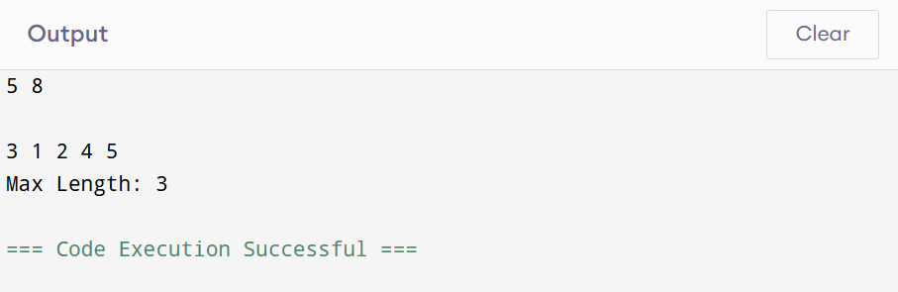
RESULT:
Thus the program finds the maximum number of consecutive tasks that can be executed without their combined energy cost exceeding the given limit 𝑃 using sliding window technique.

CATEGORY: HARD

Question 5: Sliding Window Maximum Peak (Monotonic Window Queue)
Rohan is building a real-time graphics rendering system. The system receives a sequence of frame rendering times. To smooth out frame drops, Rohan must calculate the peak (maximum) rendering time in every sliding window of 𝐾 consecutive frames.
To achieve an optimal 𝑂(𝑁) runtime, Rohan uses a monotonic double-ended queue (deque) to store indices of elements in the sliding window:
- As the window slides from left to right, maintain the deque such that indices of elements are stored in decreasing order of their corresponding values.
- For each element arr[i]:
  - Remove indices from the back of the deque if their corresponding values are less than or equal to the current element arr[i] (they can no longer be the maximum).
  - Insert the current index i at the back of the deque.
  - Remove the index from the front of the deque if it falls outside the bounds of the current sliding window (i.e., if the index is less than i - K + 1).
- For every step where the window is fully formed (when i >= K - 1), the element at the index stored at the front of the deque is the maximum for that window.
Note: Since standard C does not have a built-in deque, you can implement a basic deque using a preallocated array of size 𝑁 with front and rear pointer indices.
- The first line of input consists of two space-separated integers: 𝑁 (the total number of frames) and 𝐾 (the sliding window size).
- The second line of input consists of 𝑁 space-separated integers representing the frame rendering times.
- Print a single line of space-separated integers representing the maximum value for each sliding window of size 𝐾.
- 1 ≤ 𝐾 ≤ 𝑁 ≤ 10000
- −10⁵ ≤ 𝑎𝑟𝑟[𝑖] ≤ 10⁵
Input 1: codeText
8 3
1 3 -1 -3 5 3 6 7 Output 1: codeText 3 3 5 5 6 7 Input 2: codeText
4 2
4 3 2 1
Output 2: codeText
4 3 2
AIM:
To find the maximum element in every sliding window of size k using a Monotonic Queue (Deque) in O(N) time.

PSEUDO CODE:
Algorithm SlidingWindowMaximum(arr, n, k)
front ← 0
rear ← −1
for i ← 0 to n − 1 do

while (front ≤ rear and deque[front] < i − k + 1) do
front ← front + 1
end while

while (front ≤ rear and arr[deque[rear]] ≤ arr[i]) do
rear ← rear − 1
end while

rear ← rear + 1
deque[rear] ← i
if (i ≥ k − 1) then
print arr[deque[front]]
end if

end for

C CODE:

#include <stdio.h>
int main()
{
int n,k;
scanf("%d%d",&n,&k);
int arr[n];
for(int i=0;i<n;i++)
{
scanf("%d",&arr[i]);
}
int deque[n];
int front=0,rear=-1;
for(int i=0;i<n;i++)
{
while(front<=rear&&deque[front]<i-k+1)
{
front++;
}
while(front<=rear&&arr[deque[rear]]<=arr[i])
{
rear--;
}
deque[++rear]=i;
if(i>=k-1)
{
printf("%d ",arr[deque[front]]);
}
}
return 0;
}

OUTPUT:
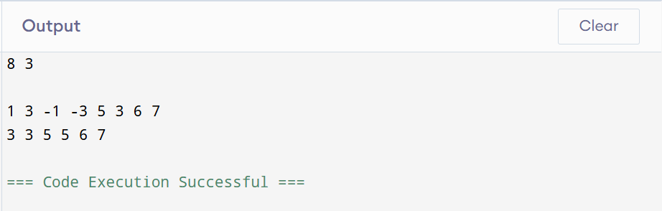
RESULT:

Thus the program finds the maximum element in every sliding window of size k using a Monotonic Queue (Deque) using sliding window

VIVA QUESTIONS:

- "We often describe a 'List' or a 'Queue' as an Abstract Data Type (ADT), while an 'Array' is a concrete data structure. In C, which lacks native object-oriented classes, how do we enforce the separation between an ADT's interface and its underlying array implementation?"

ANSWER:

- In C we separate the interface and implementation by using header (.h) and source(.c) files. The header file contains the interface(function declaration) and the source file contains the implementation (function definition)
- The user only calls the functions and cannot access the internal array directly
- This hides the implementation details and keeps ADT separate from its implementation

- "When using the two-pointer approach to find a pair with target sum 𝑇 in a sorted array, we increment left if the sum is too small, and decrement right if the sum is too large. Intuitively, why are we guaranteed not to 'miss' the correct pair by skipping elements? Why is backtracking unnecessary?"

ANSWER:

- Since the array is sorted if the sum is less than the target move the left pointer right to increase the sum and if the sum is greater than the target move the right pointer left to decrease the sum.
- The skipped pair cannot give the target sum because the array is sorted. Therefore we never miss the correct pair and backtracking is not needed.

- "If we are given an unsorted array and asked to find a target sum pair, we have two main options: sort the array first and use two pointers, or use a lookup table (hash map). How do you evaluate the trade-offs between these two approaches in a resource-constrained embedded system?"

ANSWER:

- In Sorting the array and using two pointers the Time complexity : O(N log N), Space complexity : O(N)
- But in hash map Time complexity : O(N),Space complexity : O(N)
- Hash map uses extra memory when compared to sorting the array first and using two pointers.
- So sorting the array and using two pointers is preferred

- "Why does the classic variable-size sliding window technique (expanding end and contracting start) fail to find a subarray summing to 𝑆 if the input array contains negative integers?"

ANSWER:

- The variable size sliding window works only when all the elements are positive
- With negative numbers ,adding a new element can decrease the sum and removing an element can increase the sum
- Therefore the variable size sliding window does not work with negative numbers

- "Prefix sum arrays allow us to perform range sum queries in 𝑂(1) time. However, what is the computational cost of updating a single element in the original array if we want to keep our prefix sum array valid, and how does this affect our choice of data structure?"

ANSWER:

- If one element is updated, all prefix sums after that position must also be updated.
- Update Time: O(N) , Range Sum Query: O(1)
- If updates happen frequently, Binary Indexed Tree or Segment Tree is a better choice because they support updates more efficiently.

- "When passing an array to a C function that implements a sliding window algorithm, what actually gets passed to the function? Why can't we use the sizeof operator inside the function to determine the size of our window or array?"

ANSWER:

- When an array is passed to a function, only the address of the first element is passed.
- Inside the function the array behaves like a pointer.
- sizeof(array) returns the size of the pointer, not the size of the original array.
Therefore, we must pass the array size as a separate argument

- "What major runtime vulnerability or logic error can occur when constructing a prefix sum array of a large dataset of integers in C, even if the individual elements fit within standard data types? How do we mitigate this?"

ANSWER:

- The prefix sum can become larger than the maximum value an int can store, causing integer overflow.
- To avoid this use a larger data type like long long for the prefix sum array

- "Suppose you are designing a heart rate monitor. Contrast a scenario where you would use a fixed-size sliding window with a scenario where you would use a variable-size sliding window on the sensor data."

ANSWER:

- Fixed-Size Sliding Window : Used when analyzing a fixed number of readings, such as the average heart rate over the last 10 seconds.
- Variable-Size Sliding Window : Used when the window size changes based on a condition, such as finding the smallest time period where the total heart rate exceeds a certain limit.

- "In the 'Sliding Window Maximum' problem (Hard), why can we safely discard an index 𝑗 from the back of our monotonic deque when a new element at index 𝑖 (𝑖 > 𝑗) is introduced such that arr[i] >= arr[j]?"

ANSWER:
- If arr[i] ≥ arr[j]:
- arr[i] is larger (or equal).
- arr[i] will remain in the window longer because it is newer.
- So arr[j] can never become the maximum again.
- Therefore, it is safe to remove arr[j] from the deque.

- "If we wanted to calculate the average brightness of any arbitrary sub-rectangle of an image in 𝑂(1) time, how would you extend the concept of a 1D prefix sum array to a 2D grid? What would a single 'cell' in the 2D prefix sum represent?"

ANSWER:

- We create a 2D prefix sum array.
- Each cell stores the sum of all elements from the top-left corner (0,0) to that cell (i,j).
- Using this 2D prefix sum, we can calculate the sum or average of any sub-rectangle in O(1) time.

